1. import java.util.Scanner;

public class Main{

public static void main(String[] args)

{

Venue vn = new Venue();

Scanner s = new Scanner(System.in);

System.out.println("Enter the venue name\n");

vn.name = s.nextLine();

System.out.println("Enter the city name\n");

vn.city = s.nextLine();

System.out.println("Venue "+vn.name+"\ncity "+vn.city);

} }

class Venue{

String name,city;

}

**Output:**

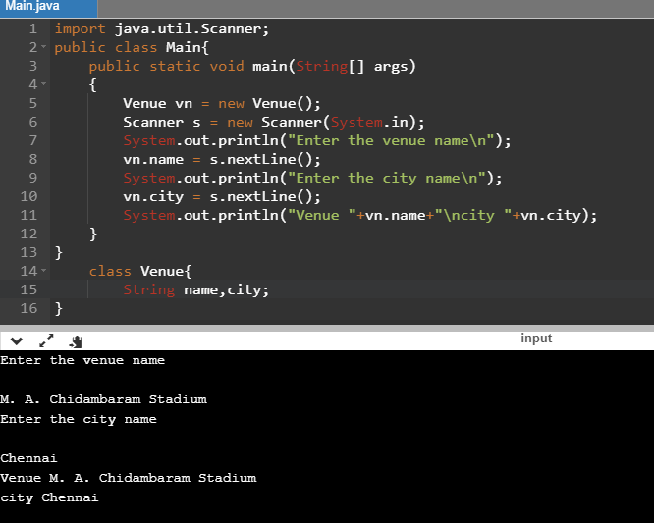

1. import java.util.Scanner;

public class Main{

public static void main(String[] args)

{

Player pl = new Player();

Scanner s = new Scanner(System.in);

System.out.println("Enter the player name\n");

pl.name = s.nextLine();

System.out.println("Enter the country name\n");

pl.country = s.nextLine();

System.out.println("Enter the skill\n");

pl.skill = s.nextLine();

System.out.println("Player "+pl.name+"\ncountry "+pl.country+"skill\n "+pl.skill);

}

}

class Player{

String name,country,skill;

}

**Output:**

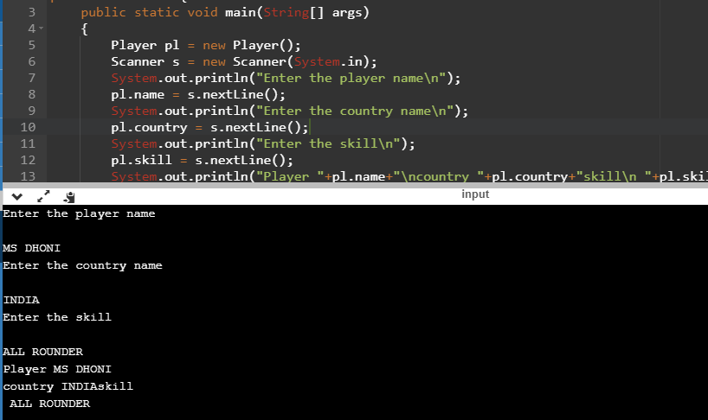

1. import java.util.Scanner;

public class Main{

public static void main(String[] args)

{

Delivery dl = new Delivery();

Scanner s = new Scanner(System.in);

System.out.println("Enter the over\n");

dl.over = s.nextLine();

System.out.println("Enter the ball\n");

dl.ball = s.nextLine();

System.out.println("Enter the runs\n");

dl.runs=s.nextLine();

System.out.println("Enter the batsman name\n");

dl.batsmanname= s.nextLine();

System.out.println("Enter the bowlername\n");

dl.bowlername = s.nextLine();

System.out.println("Enter the nonstriker name\n");

dl.nonstrikername=s.nextLine();

System.out.println("Delivery "+dl.over+"\nball "+dl.ball+"\nruns "+dl.runs+"\nbatsmanname "+dl.batsmanname+"\nbowlername "+dl.bowlername+"\nnonstrikername "+dl.nonstrikername);

}

}

class Delivery{

String over,ball,runs,batsmanname,bowlername,nonstrikername;

}

**Output:**

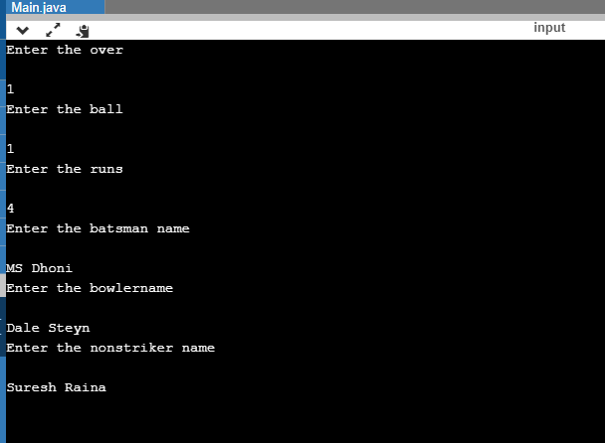

1. import java.util.Scanner;

public class Main{

public static void main(String[] args)

{

Player p = new Player();

Scanner s = new Scanner(System.in);

System.out.println("Enter the player details\n");

String input=s.nextLine();

String[] a=input.split(" , ",5);

p.name=a[0];

p.country=a[1];

p.skill=a[2];

System.out.println("Player Details \nPlayer name: "+ p.name+"\nCountry name: "+p.country+"\nSkill: "+p.skill);

}

}

class Player{

String name,country,skill;

}

**Output:**

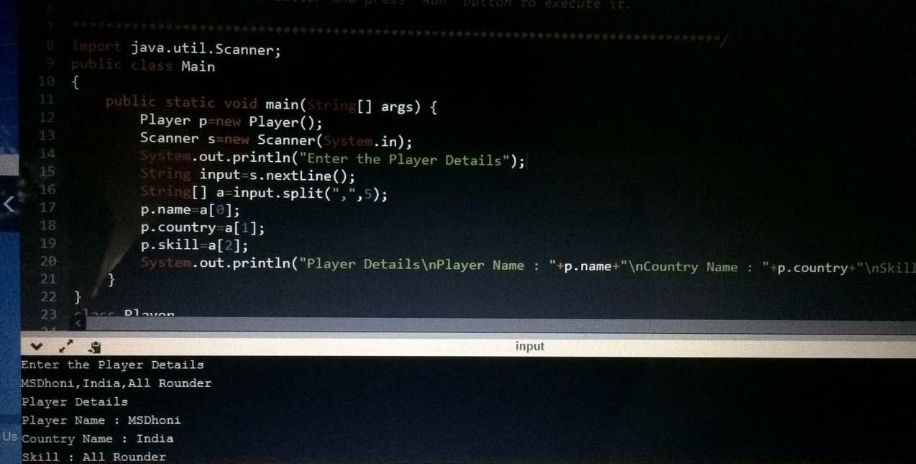

1. import java.util.Scanner;

public class Main

{

public static void main(String[] args) {

Venue vn=new Venue();

int n;

String fname,fcity,uname,ucity;

Scanner s=new Scanner(System.in);

System.out.println("Enter the venue name");

fname=s.nextLine();

System.out.println("Enter the city name");

fcity=s.nextLine();

vn.setName(fname);

vn.setCity(fcity);

System.out.println("Venue Details\nVenue Name : "+vn.getName()+"\nCity Name : "+vn.getCity());

do

{

System.out.println("Verify and Update Venue Name Details\nMenu\n1.Update Venue Name\n2.Update Venue City\n3.All informations Correct/Exit\nType 1 or 2 or 3\n");

n=s.nextInt();

if(n==1)

{

Scanner sc=new Scanner(System.in);

System.out.println("Enter the Venue Name");

fname=sc.nextLine();

vn.setName(fname);

}

else if(n==2)

{

Scanner sc=new Scanner(System.in);

System.out.println("Enter the Venue City");

fcity=sc.nextLine();

vn.setCity(fcity);

}

System.out.println("Venue Details\nVenue Name : "+vn.getName()+"\nCity Name : "+vn.getCity());

}while(n!=3);

}

}

class Venue

{

private String name,city;

public void setName(String fname)

{

this.name=fname;

}

public String getName()

{

return this.name;

}

public void setCity(String fcity)

{

this.city=fcity;

}

public String getCity()

{

return this.city;

}

}

**Output:**

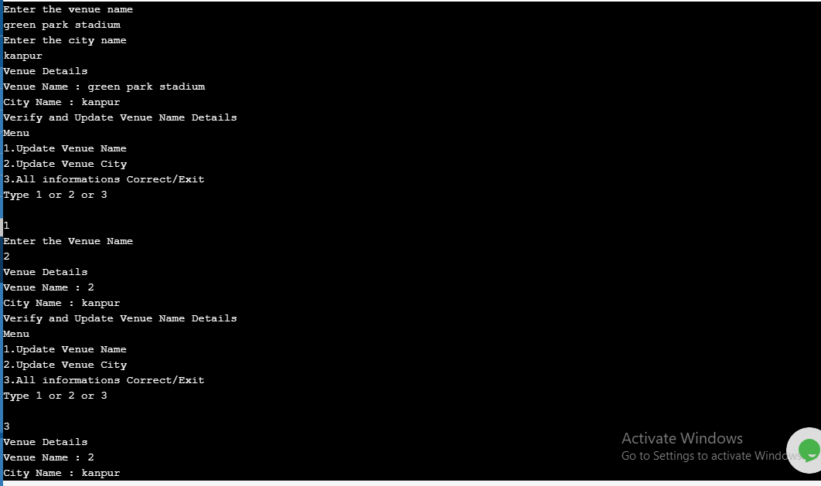

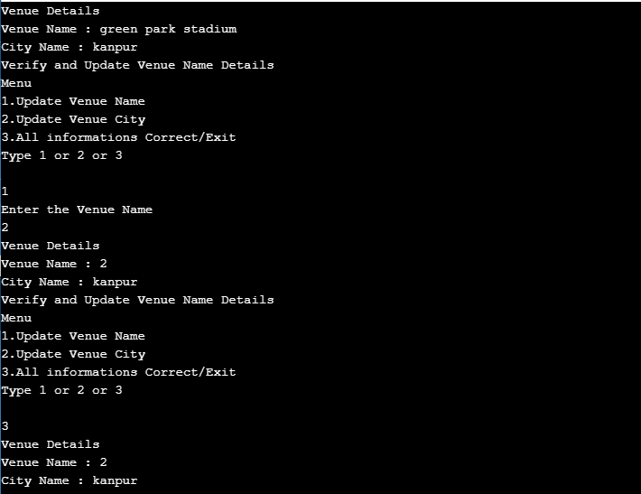

1. import java.util.Scanner;

public class Main

{

public static void main(String[] args) {

ExtraType p=new ExtraType();

Scanner s=new Scanner(System.in);

System.out.println("Enter the Details");

String input=s.nextLine();

String[] a=input.split("#",2);

p.name=a[0];

p.runs=Long.parseLong(a[1]);

//p.skill=a[2];

System.out.println("Player Details\nPlayer Name : "+p.name+"\nRuns : "+p.runs);//+"\nSkill : "+p.skill);

}

}

class ExtraType

{

String name;

long runs;

public void setName(String fname)

{

this.name=fname;

}

public String getName()

{

return this.name;

}

public void setRuns(long fruns)

{

this.runs=fruns;

}

public long getRuns()

{

return this.runs;

}

}

**Output:**

